**IBM**

**Applied Data Science Capstone Project**

**Consulting a New York business to extend its activity to Toronto**

Thomas Charitakis

April 14,2021

**1. Introduction**

Living in the 2021, due to the constant competition among businesses to take a bigger market share, a lot of shopkeepers are trying to expand their activities in new places in order to invest their profits in a proper manner. But is expanding your activity to a new place the most profitable way to invest in?

Our response is undoubtedly yes. Any business that experiences growth at home looks further afield to expand their success. Expanding into new markets presents different challenges and approaches that work for one company may not work for another. Considering localization as a key factor for global growth is essential and businesses looking to grow need to dedicate time, energy and capital to truly knowing the areas they are hoping to expand into.

Most companies looking to expand into new markets want to boost their sales and have identified a market in which they can see the potential for growth. This can be a fine balance to achieve, as you need to ensure you keep current, loyal customers on side while impressing and persuading customers in the new region.

But of course you do not need to keep all of this in mind. As a company expertizing in consulting companies about strategies and organization matters we will make your life easy about what your next step should be and how to expand your business in a expedient way

**2. Business problem**

Due to the congested New York city a lot of businesses have come to us asking how to expand their activities in new places even it means to move to a new country. Depending on the market growth and news, Toronto is a city that is growing in a rapid tempo.

So as a consulting company we decided to make an analysis on the boroughs of New York and Toronto to see how close these cities are to each other in terms of market style and chances so that we can propose to our customers to move there.

**3. Data Acquisition and Presentation**

In order to fulfill our goal we needed to acquire data about demographic info for both cities in order to compare them and see where the main chances would be. We should get some data referring to the boroughs of each city, their neighborhoods and the venues that each city accommodates. Of course we need to get information about the coordinates of each neighborhood so that we can utilize the Foursquare API so that we can get the venues later in the process.

We found the New York Data from the IBM Developer Skills Network as there were a dataset ready to use, and we got our hands on to Toronto demographic data from a postal code list of the city in Wikipedia. We utilized the request, pandas and beautiful soup in order to store the data in pandas dataframe. The datasets are loaded and ready to proceed as you can see below.

**New York Dataset**

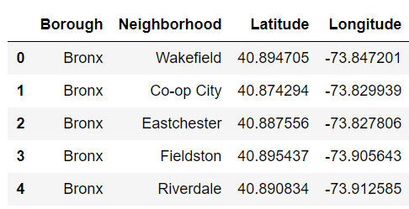

**Toronto Dataset**

